

Agent Based Software Engineering  
*LabTask 04*

Name : Muhammad Shamoil  
Section : BSSE – V – A  
Date: 23rd Oct , 2023  
Submitted To : Sir Waseem Wahid

# Task 01

# Task 02

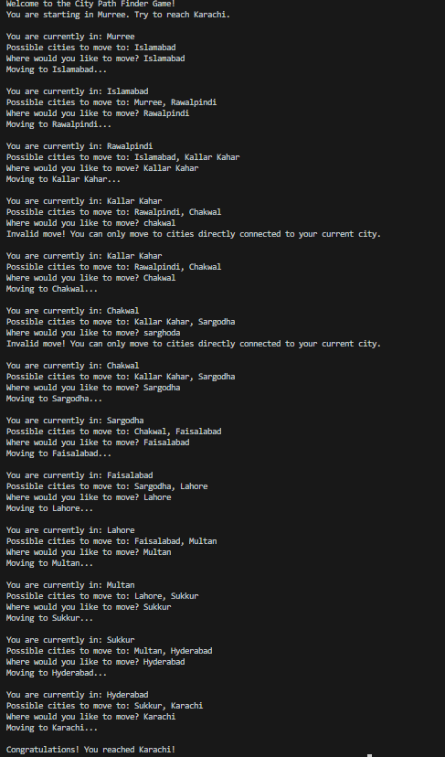

# Task 03



